**Prashant Shukla**

**Wholesale Market Descriptive Analysis**

**Introduction**

The market for the sale of goods to a retailer is known as a wholesale market. A wholesaler receives huge quantities of goods and products from the manufacturing unit and it then sells them off to the retail stores. The consumers buy these products from the retail stores. The price at which the wholesaler buys the goods from the manufacturer is quite less as huge stocks are bought in one go. The price is much lesser than the case in which individual retail stores buy them from the manufacturer.

Initially, wholesalers used to be closer to the markets to which they supplied, rather than the source through which they got the products. In today’s scenario with the emergence of the internet and e-procurement, most of the retailers have started locating near the manufacturers. There are several channels which are being used to send the products.

**Goal**

The main goal of this project is to analyze the wholesale market in certain states of the US. It is very important to analyze the current trend in demand of the customers, in order to avoid heavy losses. The supply of products should be as per the demand of the market. Both of these should go hand in hand in order to obtain profits.

**Columns and their data types:**

|  |  |  |
| --- | --- | --- |
| Column Name | Description | Type |
| Location | US State | Text |
| Year | Year of the record. | Text |
| Channel | Customer’s channel: Horeca - 1, Retail - 2 | Text |
| Region | Customer’s region: Lisnon - 1, Oporto - 2, Other - 3 | Text |
| Fresh | annual spending (m.u.) on fresh products | Floating-point number |
| Milk | annual spending (m.u.) on milk products | Integer |
| Grocery | annual spending (m.u.) on grocery products | Floating-point number |
| Frozen | annual spending (m.u.) on frozen products | Integer |
| Detergents_Paper | annual spending (m.u.) on detergents and paper products | Floating-point number |
| Delicassen | annual spending (m.u.) on and delicatessen products. | Integer |

**Milestones**

1. **Data Acquisition**

The data was acquired from the website <https://archive.ics.uci.edu/ml/datasets/Wholesale+customers> in the form of a csv file. The file then was introduced to python programming language.

I used python language to obtain the data from a csv file and turned it into a useable form by performing a certain cleaning technique. There are certain libraries that I used, to perform different kinds of functionality, for which I have used the python script.

**Code:**

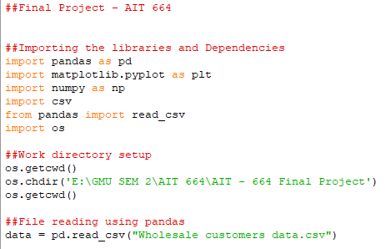

**Dataset read:**

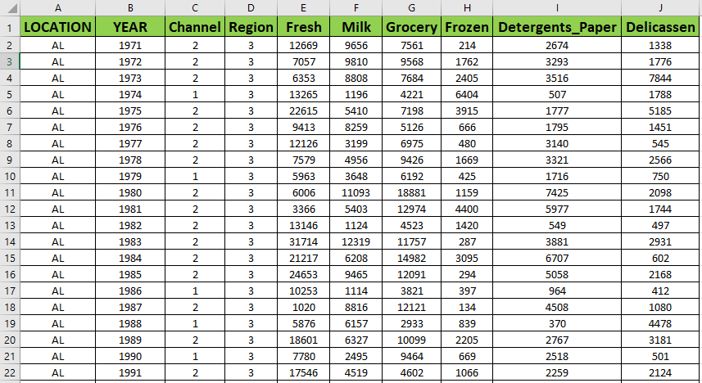

1. **Data Preprocessing**

The data contained certain missing values in few of the columns. I checked their count with the help of a predefined function. Later, I used the mean of that column and filled in the missing values with this mean value of that particular column. I converted the data type of these columns to float data type, in order to accommodate the mean value, which was a float type. I changed the data type of some fixed columns to string data type.

**Code:**

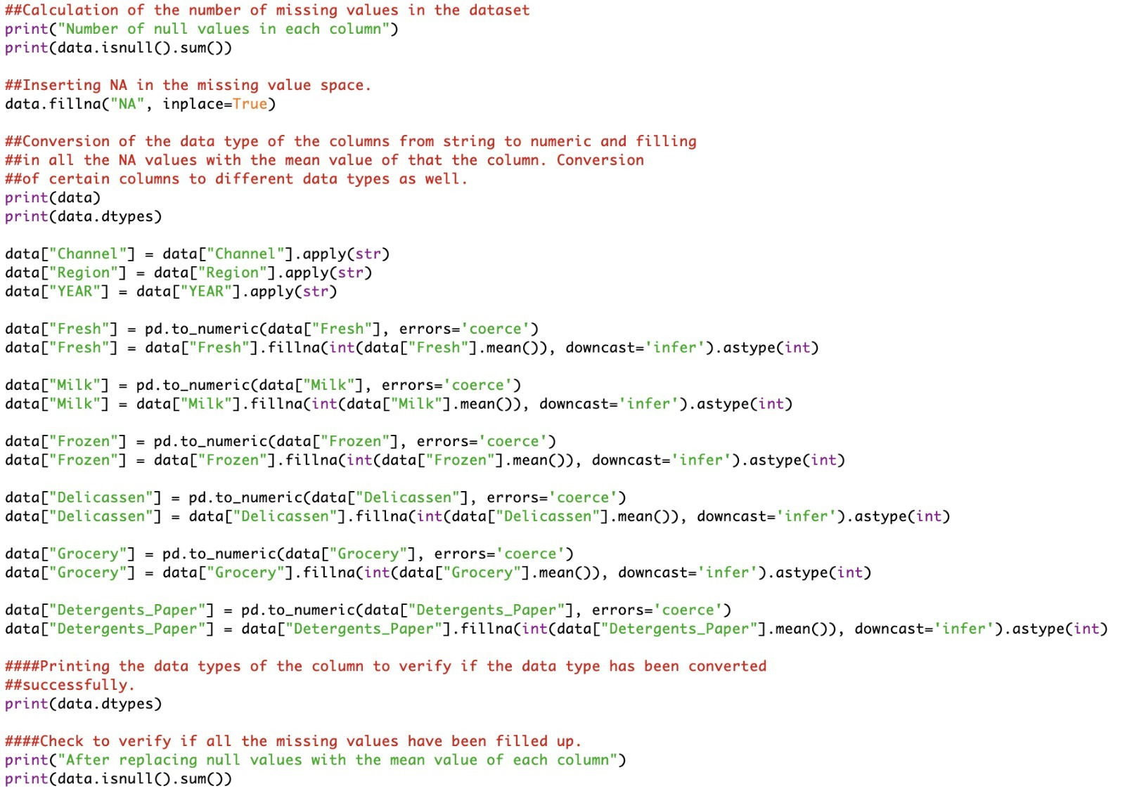

**Output:**

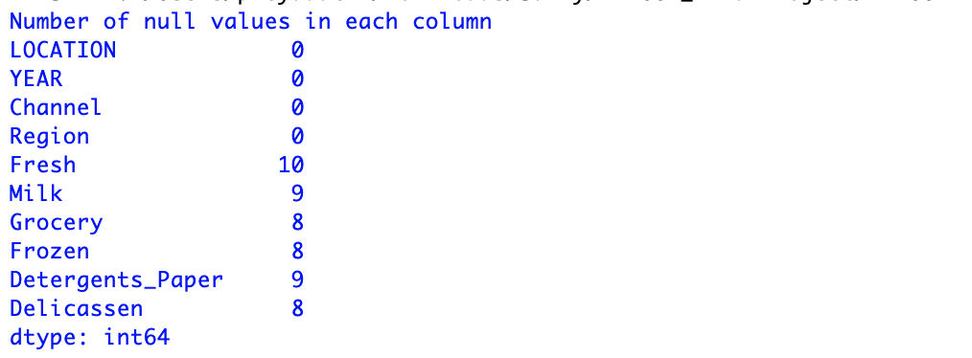

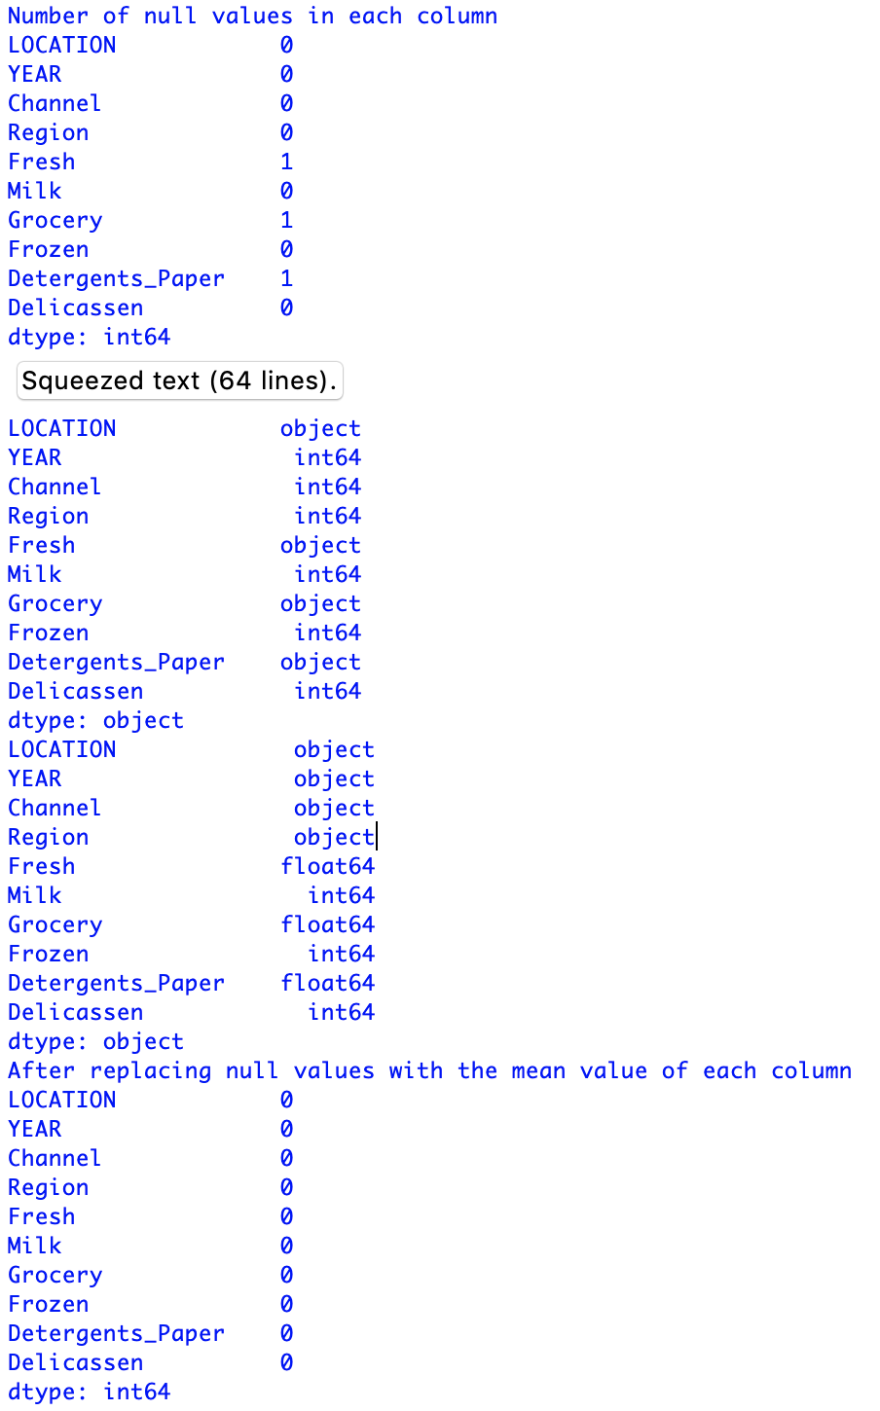

1. **Mining Tool Preparation**

A summary of the dataset is displayed by using the summary function.

**Code:**

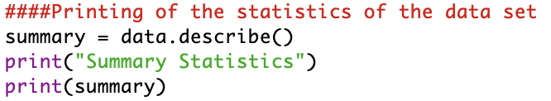

**Output:**

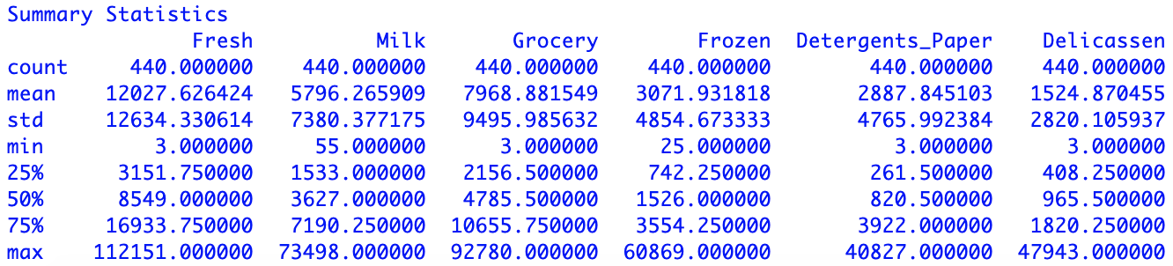

The file containing all the changes that have been made on the dataset, i.e. the clean data set, is exported to a comma separated file.

**Code:**



This data was then introduced to R where the analysis was done and the visualizations were then after made.

1. **Clustering Analysis**

After obtaining the summary of the dataset, there is a noticeable difference between the minimum and maximum values in all the columns of the dataset. The maximum value of milk varies from 55 to 73498. The top customers would have this value to be really high, in comparison to the lower ones. However, from a business point of view, it is not really required to analyze the expenditure of the top customers. They can basically be considered as outliers. They cannot be removed by doing any kind of normalization, but a log transformation may prove to be useful. It is not required that the algorithm for clustering need the expenditure made by the top customers. The middle ones require clustering and segmentation.

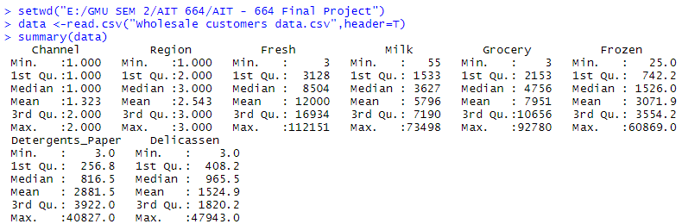

I removed the top 5 entries in the code from all the columns and created a new data set.

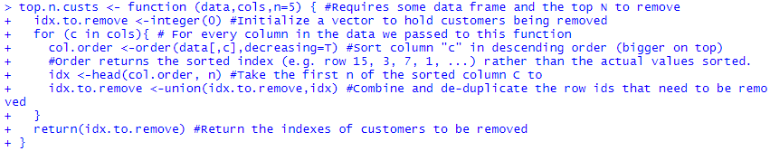

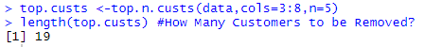Then we check how many numbers of customers have we removed.

Usingthedataset that has been obtained from the above code, cluster analysis can be performed on it. The first four columns of the dataset, Location, Year, Channel and Region can be excluded as they cannot contribute in the clustering process.



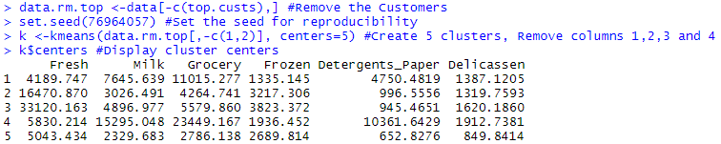**Output:**

**Interpretation**

**Cluster 3** – Contains most of the fresh category products.

**Cluster 1** – It appears to have grocery at quite a high level, fresh food at a lower level and detergents paper at a level little more than the medium one.

**Cluster 5** – It mostly depicts the small customers and can be considered to be a small store of all different kinds of products.

**Withness and Betweenss:**

**Betweenss** – It is the sum obtained of the squared distance between the centers of the clusters. A perfect scenario is where the centers are quite far away from each other.

**Withness** – It can be termed as the sum of the square of the distance between data points and the center of the clusters. A lesser value is considered to be good. There is either a requirement of creating more clusters and also the presence of several outliers.

**Finding the appropriate number of clusters:**

Betweenss and withness can be plotted into a graph in order to compare them. Their comparison gives the elbow point. An elbow point signifies the optimum number of clusters that should be created for a particular dataset. The point where the graph bends and does not make any more progress in withness, is the K point. I have set the range between 2 and 20 and the graph, in order to trace the elbow point.

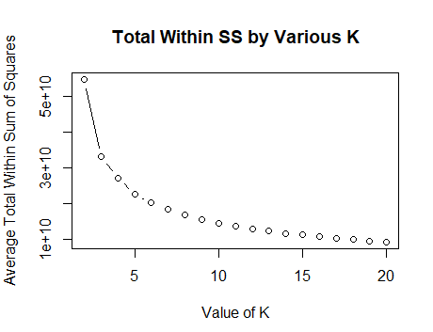

The plot that has been obtained does not contain a distinct elbow point. As per the graph 5 seems to be the K point for this dataset.

Now we have 5 different clusters. We now checked the number of data points in each cluster.

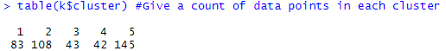

Further analysis demands, setting up vectors for the analysis and plotting.

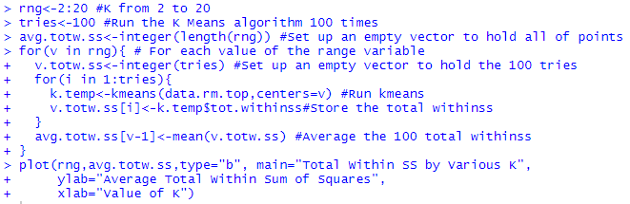

1. **Visualizations**
2. **Plot Interpretations**

**Plot 1**



The plot here shows the cluster density VS the expansion of the cluster. It can be clearly seen from the plot that the cluster is 5 has a noticeable amount of garbage values which shows that the customers did not follow any buying trends and were just buying stuff on a random basis, but as time passed, customers changed the pattern of buying which is represented by the other clusters as they expand throughout the plot and become lesser dense showing varied pattern.

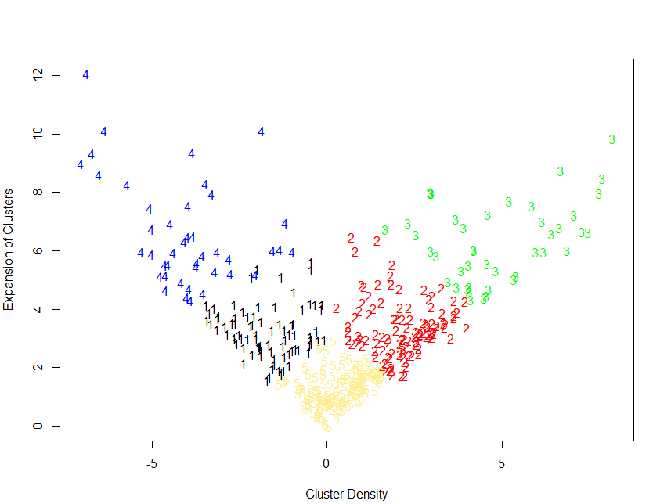

**Plot 2**



The plot shows the point variability of the component density, that is the Expense density of the wholesale goods in the market. It represents the market trends of how variably the people buy goods and how frequent is the supply to the demand. We can clearly see that cluster 5 is the densest and cluster 4 is the most vastly expanded. This shows that there was a better trend in the goods purchase with the change in different types of purchase that happened during a long span of time.

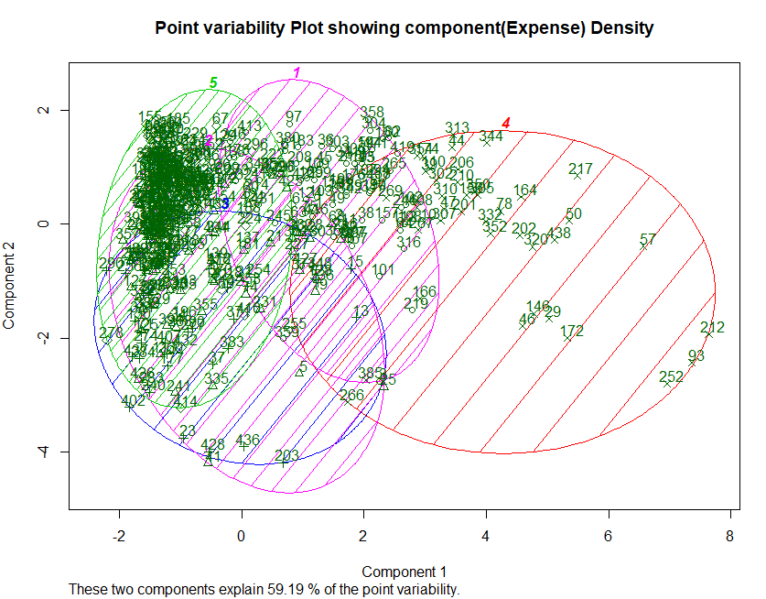

**Plot 3**



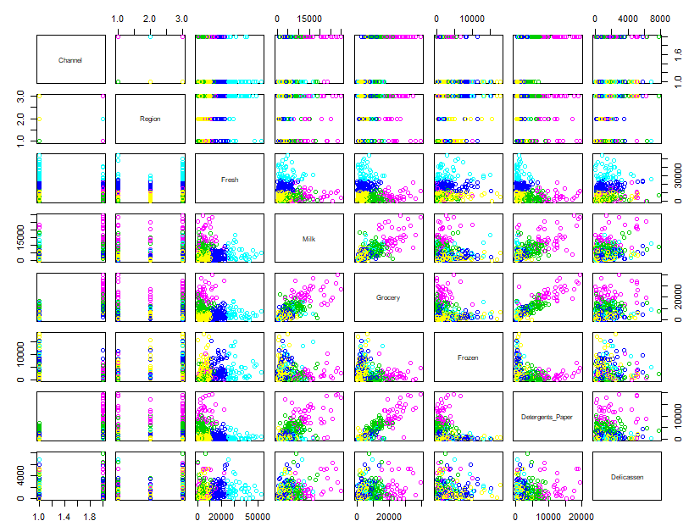

The above plot shows the variables and their veracity among other variables. Based on these six variables and their distribution plots one can analyze which one is to be held back and which one to be sent for production. The variable goods expenses are either dense or are scarce in a corner, while some are vastly distributed. One can easily see how to manage the market demand by looking at the graph where each variable column shows the cluster density with relation to other variable goods.

**Trend and Pattern Plots**

1. **Line Plot**

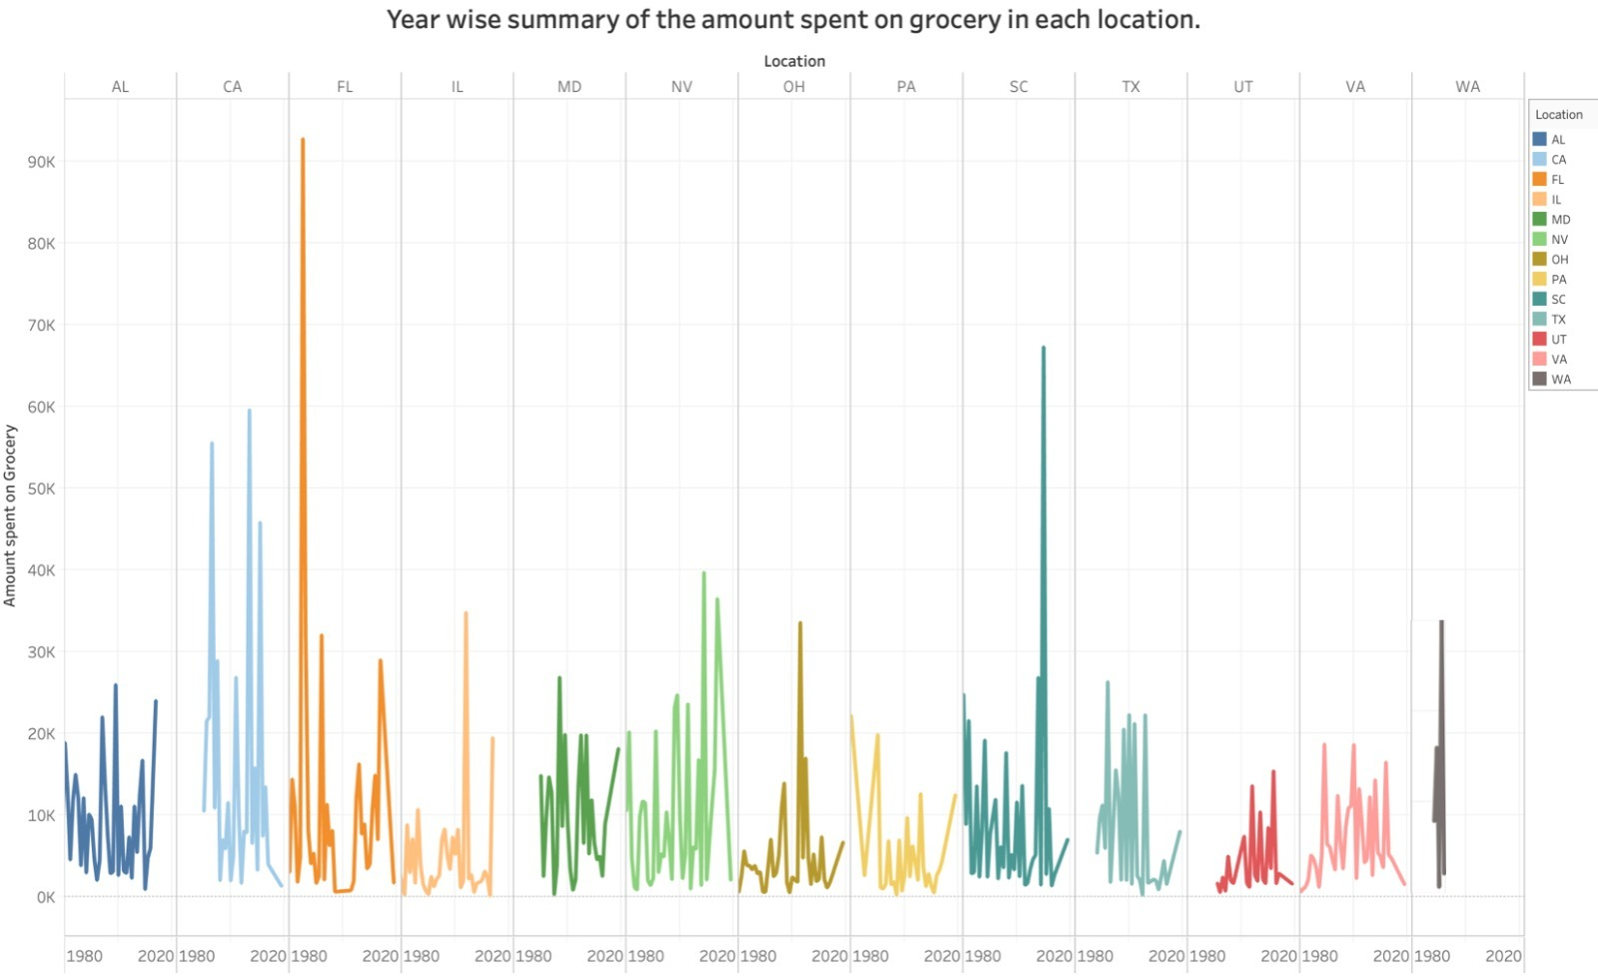

The above line plot is a representation of the buying pattern of grocery in the wholesale market of various states of the US. This is a year wise distributed summary.

As per the graph the amount that has been spent in Florida in the year range of 1980 - 2000 has been the highest until now. There could be two possible reasons for this plot being the highest. The population of Florida might be much more than that of the other states in that particular year range or else there might have been big customers would have invested a lot in the wholesale market. However, as the line is not constantly high, this in itself, signifies that it is not the population which played a major role in this case but mostly an investment from a high-end customer of the wholesale market, who invested a huge amount in the market. The lowest variation in the pattern can be noticed in Texas. The reasons can be both, lower population or else low-end customers.

**Data:** Yearly expense of the amount spend on groceries in each location.

**Information:** The amount of expenses varies from each state to state.

**Knowledge:** The amount of expenses varies due to the buying trends of the people in various states.

**Wisdom:** I am able to understand and infer that the amount of funds spent on grocery shopping from 1980 to 2020 had a huge changeover which instilled a lot of losses to the wholesale market and thus the management needs to think about the manufacturing and selling patterns to the customer outlets.

1. **Stacked bar chart**



This chart signifies the percentage distribution of the amounts spent on the fresh and the frozen food available in the wholesale market. As per the graph the maximum difference between the amount spent on the two kinds of food is in the state of Alabama, i.e. 5.36. The majority of the people in this state prefer eating fresh food in comparison to the frozen food. It can be inferred from the graph that they are conscious about their fitness and take good care of their health.

There is a major difference between the percentages in the state of North Carolina as well, i.e. 4.41. On the contrary, the people in this state prefer eating frozen food in comparison to the fresh food, in order to save time. They are not much concerned about their health.

**Data:** Percentage of the amount spend on Fresh and Frozen foods in different states.

**Information:** The percentage ofamount that is spend on both the categories of food is quite near to a total of 22% out of 100%.

**Knowledge:** The amount of expenses is higher on the fresh foods side rather than the frozen ones.

**Wisdom:** I am able to understand and infer that the amount of funds spent on fresh foods are more because the people prefer to eat more of the fresh food everyday rather than depending on the frozen food. Also, Washington is the only state where percentage of both the categories are really low.

1. **Pie Chart**



The pie chart is a percentage comparison chart of the amount spent on the groceries, in the various states. The highest percentage is in Florida, i.e. 12.73%., and the lowest is in Washington, i.e. 1.70%. Accordingly, should the market be supplied with the groceries. The channels should carry the number of goods, according to the demand in that particular state. If the supply increases the demand, heavy losses will be suffered in that case.

**Data:** Percentage of the amount spent on grocery in different states on the whole.

**Information:** The amount of expenses varies from each state to state.

**Knowledge:** The amount of expenses has a huge variation due to the buying trends of the people in various states.

**Wisdom:** I am able to understand and infer that the amount of funds spent on grocery shopping on the whole told us a lot about how the people spend and what kind of pattern is followed when calculated on a whole or say complete level.

1. **Bar Chart - Detergents Paper**



This chart shows the difference between the amount spent on Detergents Paper in the different states of US. It has been plotted by using the python script. As per the graph the highest amount was spent in Alabama on this particular product. While, in Washington DC the amount spent on it was almost equivalent to null. The reason behind this can be that the residents of this Alabama find Detergent paper to be a more convenient option than the other detergent options. The graph has been depicted in a sorted order of expenditure.

**Data:** Location wise amount spend on Detergents Paper.

**Information:** The amount of expenses varies on a big scale from ranging from Alabama to Washington.

**Knowledge:** The amount of expenses varies on a very large scale and is greatest in Alabama while lowest or none in Washington.

**Wisdom:** I am able to understand and infer that the amount of funds spent on Detergents paper is quite large in Alabama due to the extreme usage in that state while in Washington there is none.

1. **Bar Chart - Milk**



This graph contains a year wise distribution of the expenditure made on milk. On arranging the bars, it was found that with the advancement of time, the consumption of milk has reduced every year. The only exception to this pattern is the year 1970, wherein there was a sudden rise in the following year. The reason behind this can be inferred as the introduction of dairy farms in 1971, which brought a sudden rise in the supply and consumption of milk. Whereas, the price of milk would have been increased in the following years, which could not be afforded by the lower section of the society as they had to start using other alternatives of milk.

**Data:** Yearly expense of the amount spend on milk in each location.

**Information:** The amount of expenses varies from each year to year in a linear manner.

**Knowledge:** The amount of expenses varies due to dairy farms that opened in the year 1971.

**Wisdom:** I am able to understand and infer that the amount of funds spent on milk from 1980 to 2015 have a linear flow as can be seen in the plot, because the time after the introduction of milk farm in the US, getting milk became easier and as this is a daily usage product it was used in abundance. But as the years passed the usage trends changed and it depleted with a steep downfall and became kind of constant throughout the years with usage being normalized.

1. **Box and Whiskers plot**

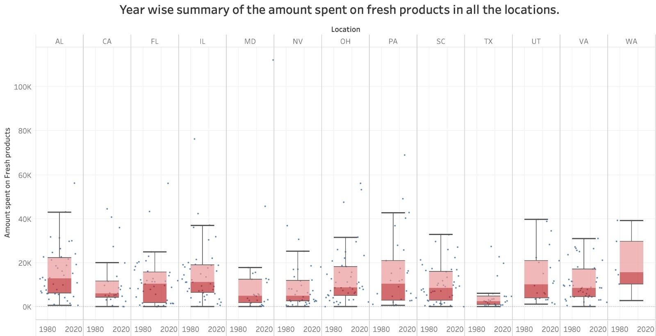

This graph helps in studying the distributional characteristics of a group values and it also gives and understanding of the level of the values. The values are sorted in the very beginning and then four equal distributions are made with help of lines that are known as quartiles and the groups are termed as quartile groups. The plots can be split into the below parts:

**Whiskers:** It signifies the values outside the middle 50%.

**Median:** It signifies the midpoint of the values.

**Inter-quartile range:** It is made up of the lower and upper quartiles, divided by the median. The middle 50% values come under this range.

The above box plot has been plotted based on the amount spent on the fresh food products in various states of the US. As per the plot the box plot for Texas is the smallest. This shows that there is a very small difference between the amount that has been invested by the high- and low-end customers, respectively. The box plot of Washington is not equally distributed across the median. This signifies that there is a huge difference between the amounts spent by the high-end customers, among themselves, as compared to the difference between the amounts of the low-end customers.

1. 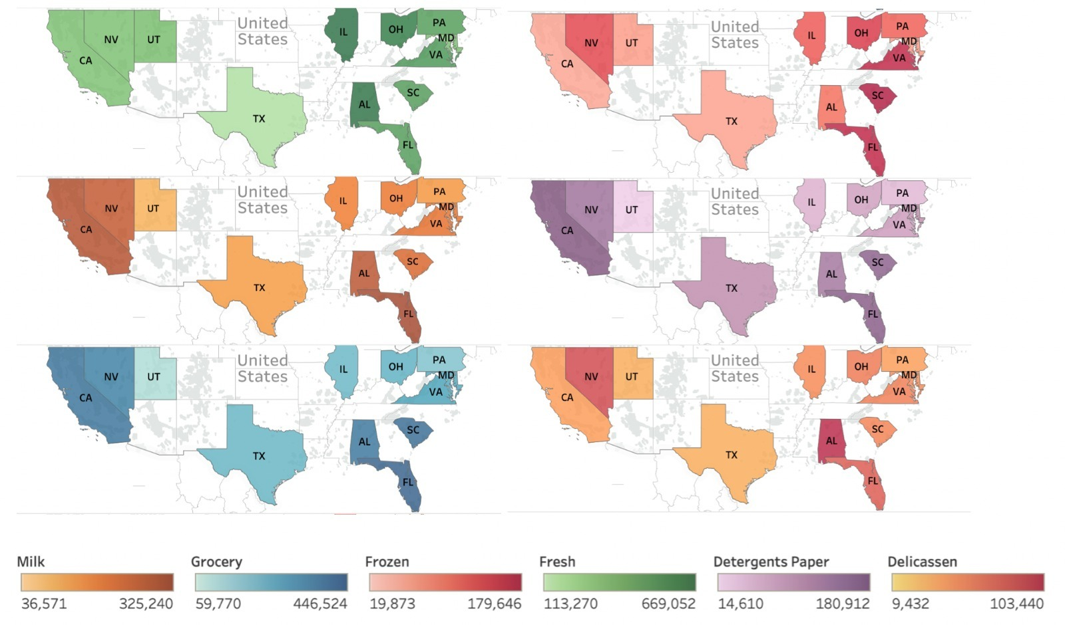**US – Map Plot**

The above graph shows the ranging demand and varying expenses of every good that is sold in the various states of the US. It clearly shows that there are states which do not require as much of the wholesale goods as the other do. Still large amount of production and sale is going on without realizing the losses that the vendors are going through which in turn is destroying the economical balance of the industry. According to recent facts The United States are under a debt of about $22.22 trillion, where the above given losses constitute a percentage of 19.67%, which is a huge amount and can be saved if the wholesale market functions in a well-managed manner.

**Conclusion**

It is a very important task to monitor the demand in all of the states in US. The supply in the various regions should be set accordingly, and the channels should be efficient enough to handle the supply of a wholesale market in a particular state. This is the only way that this business can stay in profit and avoid heavy losses. It totally depends on the choice and the level of the customers in a particular region.

The bar chart for milk has shown a clear picture of the amount spent on it getting reduced every year. This is a clear indication of its price being unaffordable. If this trend continues the milk department of the wholesale market will suffer huge losses. Therefore, efforts should be made to make the price affordable. Its price can also be altered by changing the channel that it is currently being used. There are certain taxes on different channels, which tend to make the product expensive.

The observation that is common in all the different kinds of analysis that have been done in this project is that the demand in the wholesale market for all of the products that are present in the data set, is low. Therefore, somewhere or the other this reflects that the prices for all of these products is not that affordable in this state. One way of bringing the prices down would be by opting for a cheaper channel, in order to cut short, the transport charges. However, there shouldn’t be an increase in the supply this state or else it will incur heavy losses.

**Citations – References**

1. Dua, D. and Graff, C. (2019). UCI Machine Learning Repository [http://archive.ics.uci.edu/ml]. Irvine, CA: University of California, School of Information and Computer Science.
2. Forgey, E. (1965). “Cluster Analysis of Multivariate Data: Efficiency vs. Interpretability of Classification”. In: Biometrics.
3. Lloyd, S. (1982). “Least Squares Quantization in PCM”. In: IEEE Trans. Information Theory.

1. Hartigan, J. A. and M. A. Wong (1979). “Algorithm AS 136: A k-means clustering algorithm”. In: Applied Statistics 28.1, pp. 100–108.

1. MacQueen, J. B. (1967). “Some Methods for classification and Analysis of Multivariate Observations”. In: Berkeley Symposium on Mathematical Statistics and Probability